Authors’ Note: None of these data are mutually exclusive (e.g. services often had more than one characteristic and the presence of one characteristic did not exclude the possibility of other characteristics noted).

Presence of a Fee
Service Fees | Number of Instances
Fees for all projects or unspecified | 6
Fee if project is funded | 6
Fee for non-affiliates | 2

Fee Structure
Fee Calculation | Number of Instances
By time | 6
By tier | 6
By database searched | 1
Flat rate | 2

Explicitly Included Populations by Tier Type
Tier (N of schools with this level) | Populations available to
Untiered (n=41) | 17% (n=7) available to faculty and researchers  15% (n=6) available to all affiliates  10% (n=4) available to specific colleges or departments  2% (n=1) available to graduate students and undergraduate medical students  2% (n=1) available to outside parties
Instructor (n=21) | 24% (n=5) available to a particular college or department  19% (n=4) available to all university affiliates  5% (n=1) available to faculty and researchers  5% (n=1) available to all students
Consultant (n=73) | 44% (n=32) available to all affiliates  14% (n=10) available to faculty and researchers  12% (n=9) available to a specific college or department  7% (n=5) available to graduate students and medical students  3% (n=2) available to all students  1% (n=1) available to outside parties
Team Member (n=73) | 23% (n=17) available to all affiliates  23% (n=17) available to faculty and researchers  16%(n=12) available to specific college or department  8% (n=6) available to graduate students and undergraduate medical student  3% (n=2) available to outside parties

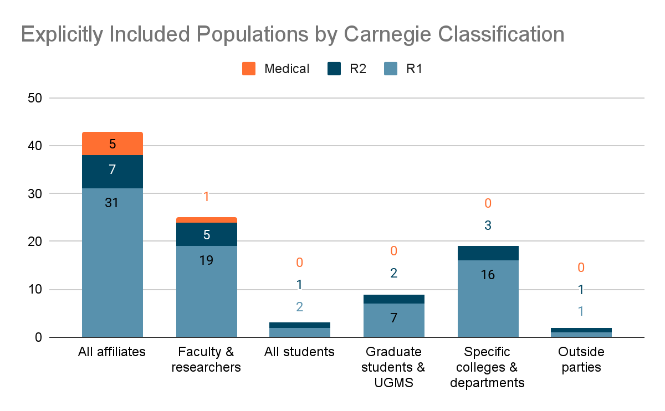
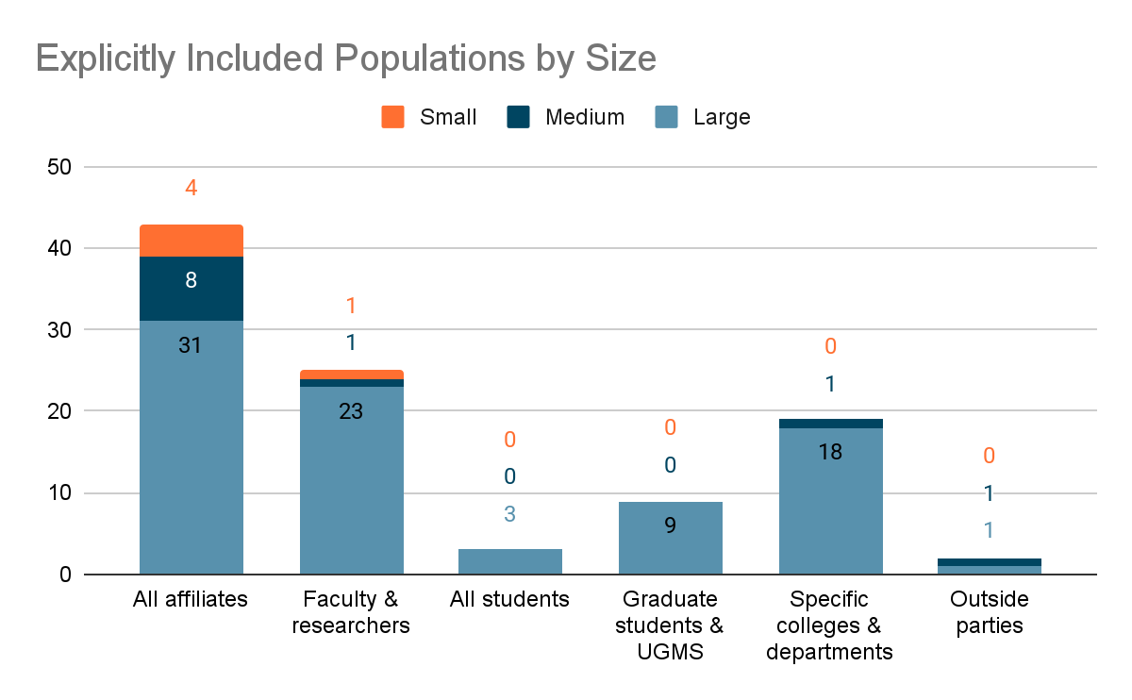

Rationalization of Information Professional Involvement
Rational Source | Number of Services
International Committee of Medical Journal Editors (ICMJE) | 29
Institute of Medicine (IOM) | 22
Journal of the American Medical Association (JAMA) | 3
Cochrane Handbook for Systematic Reviews | 12
JBI Manual for Evidence Synthesis | 1
Other | 25
None | 58

Duties Associated with Authorship
Characteristic/Behavior | N of Services
Writes search methods | 96% (n=27)
Writes search strategy | 93% (n=26)
Executes search & exports results | 89% (n=25)
Manages citation/screening software | 54% (n=15)
Deduplicates results | 54% (n=15)
Completes flow diagram | 46% (n=13)
Reviews manuscript | 46% (n=13)
Participates in protocol creation | 43% (n=12)
Recommends databases | 39% (n=11)
Retrieves full-text articles | 25% (n=7)
Assist in question/PICO development | 25% (n=7)
Pre-search for existing systematic reviews/protocol | 18% (n=5)
Provides basic instruction on evidence synthesis (process and methods) | 18% (n=5)
Suggests revisions to search strategies | 18% (n=5)
Instructs team on use of citation/screening software | 18% (n=5)
Instructs team on protocol registration | 14% (n=4)
Suggests journals for publication | 11% (n=3)

Mention of Population by Institution Type and Size Setting
Carnegie Classification - Research Activity | N of Services that Mention Population
R1 | 50
R2 | 12
Medical Schools & Centers | 5
Carnegie Classification - Size & Setting | N of Services that Mention Population
Very Small (<1,000 FTE) | 0
Small (1,000-2,999 FTE) | 4
Medium (3,000-9,999 FTE) | 8
Large (≥10,000 FTE) | 55
Total that Mention Population | 67

Presence of a Fee by Institution Type and Size Setting
Institution Types | N have Presence of Fee
R1 (84) | 9
R2 (25) | 2
Medical (7) | 0
Size of School
Very Small | 0
Small | 0
Medium | 3
Large | 8
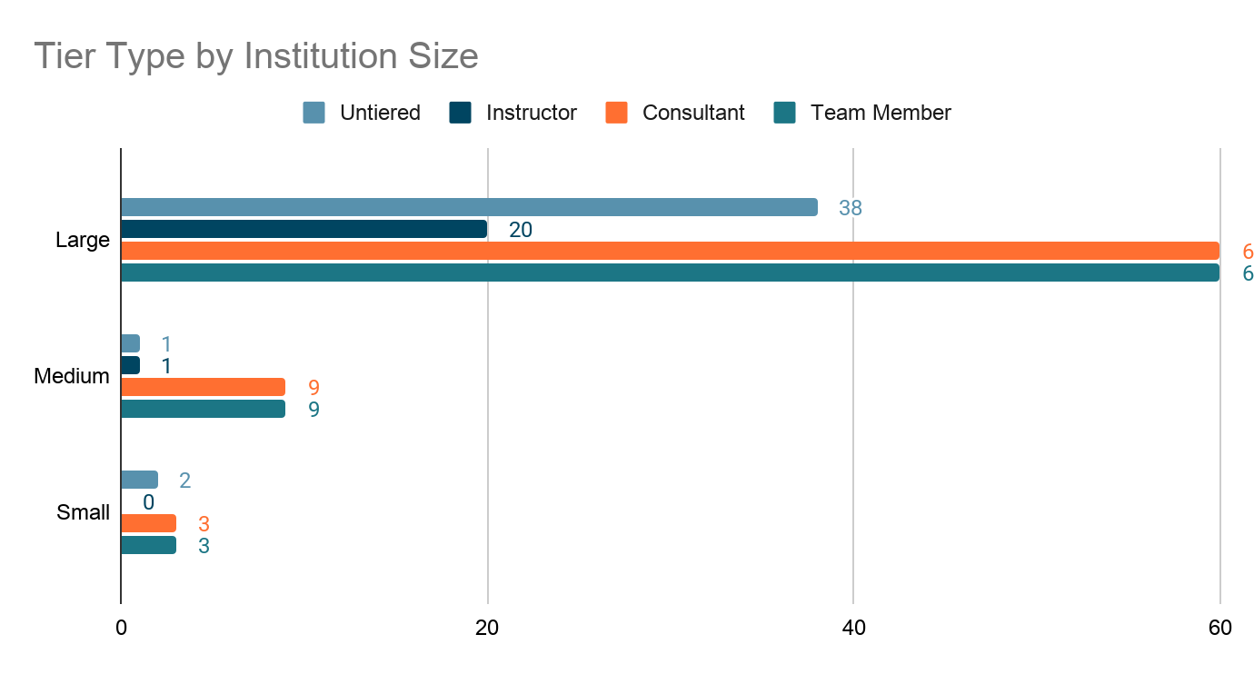

Top 5 Duties (by Percentage) by Tier in R1 Schools
Tier (N of R1 schools with this level) | Included Duties (N of schools that list this duty)
Untiered (29) | 59% (n=17) Recommends databases/search environments  55% (n=16) Writes final search strategy and translations  55% (n=16) Provides basic instruction on evidence synthesis (process and methods)  52% (n=15) Develops and/or revises initial search strategies  48% (n=14) Assist in question/PICO development
Instructor (16) | 81% (n=13) Provides basic instruction on evidence synthesis (process and methods)  44% (n=7) Develops and/or revises initial search strategies  38% (n=6) Recommends databases/search environments  31% (n=5) Instructs team on use of citation/screening software  13% (n=2) Assist in question/PICO development
Consultant (54) | 80% (n=43) Develops and/or revises initial search strategies  70% (n=38) Recommends databases/search environments  65% (n=35) Instructs team on use of citation/screening software  63% (n=34) Provides basic instruction on evidence synthesis (process and methods)  37% (n=20) Assist in question/PICO development
Team Member (53) | 98% (n=52) Writes search methods  98% (n=52) Writes final search strategy and translations  94% (n=50) Executes search & exports results  74% (n=39) Manages citation/screening software  72% (n=38) Completes flow diagram

Top 5 Duties (by Percentage) by Tier in R2 Schools
Tier (N of R2 schools with this level) | Included Duties (N of schools that list this duty)
Untiered (10) | 70% (n=7) Develops and/or revises initial search strategies  60% (n=6) Recommends databases/search environments  60% (n=6) Instructs team on use of citation/screening software  50% (n=5) Writes final search strategy and translations  50% (n=5) Executes search & exports results
Instructor (5) | 100% (n=5) Provides basic instruction on evidence synthesis (process and methods)  60% (n=3) Recommends databases/search environments  60% (n=3) Instructs team on use of citation/screening software  40% (n=2) Develops and/or revises initial search strategies  20% (n=1) Instructs team on protocol registration  20% (n=1) Retrieves full-text articles
Consultant (14) | 71% (n=10) Develops and/or revises initial search strategies  64% (n=9) Recommends databases/search environments  57% (n=8) Provides basic instruction on evidence synthesis (process and methods)  50% (n=7) Assist in question/PICO development  43% (n=6) Instructs team on use of citation/screening software
Team Member (15) | 100% (n=15) Writes search methods  93% (n=14) Writes final search strategy and translations  67% (n=10) Executes search & exports results  47% (n=7) Deduplicates results  33% (n=5) Reviews manuscript  33% (n=5) Completes flow diagram  33% (n=5) Manages citation/screening software  33% (n=5) Instructs team on use of citation/screening software  33% (n=5) Recommends databases/search environments

Top 5 Duties (by Percentage) by Tier in Medical Schools
Tier (N of R2 schools with this level) | Included Duties (N of schools that list this duty)
Untiered (2) | Not enough data. Only one of the two schools provided actual duties in this tier.
Instructor (0)
Consultant (5) | 100% (n=5) Provides basic instruction on evidence synthesis (process and methods)  100% (n=5) Recommends databases/search environments  100% (n=5) Develops and/or revises initial search strategies  60% (n=3) Assist in question/PICO development  40% (n=2) Pre-search for existing systematic reviews/protocol  40% (n=2) Instructs team on protocol registration
Team Member (5) | 100% (n=5)Writes final search strategy and translations  100% (n=5) Executes search & exports results  100% (n=5) Writes search methods  60% (n=4) Recommends databases/search environments  60% (n=4) Manages citation/screening software

